

# Netradyne Mail Nickname Update Greenhouse

Procedure

v1.2

Internal and Confidential

***Table of Contents***

Document Control 2

1. PURPOSE 3
2. SCOPE 3
3. ROLES AND RESPONSIBILITIES 3
4. PROCEDURE 3
5. CONDUCT 3
6. EXCEPTION 5
7. TERMS/ACRONYMS 5
8. REFERENCES 5
   1. Policies 5
   2. Process/Procedures 5
9. APPENDIX A: DOCUMENT RACI MATRIX 5

### Document Control

|  |  |
| --- | --- |
| **Document ID** | NDMN2024001 |
| **Document Name** | Netradyne Mail Nickname Update Greenhouse Procedure |
| **Document Status** | Released |
| **Document Released Date** | 12-12-2024 |
| **Document Author** | [mauricio.taxman@netradyne.com](mailto:mauricio.taxman@netradyne.com) |
| **Document Content Contributors** | [priyesh.parashar@netradyne.com](mailto:priyesh.parashar@netradyne.com) |
| **Document Signatory** | [chethan.gangaraju@netradyne.com](mailto:chethan.gangaraju@netradyne.com) |
| **Document Owner** | [mauricio.taxman@netradyne.com](mailto:mauricio.taxman@netradyne.com) |
| **Document Version** | V1.2 |
| **Information Classification** | Internal |

**Document Edit History**

|  |  |  |  |
| --- | --- | --- | --- |
| **Version** | **Date** | **Additions/Modifications** | **Prepared/Revised By** |
| V1.0 | 25-Nov-2024 | Document Prepared | Mauricio Taxman |
| V1.0 | 25-Nov-2024 | Document Prepared | Mauricio Taxman |
| V1.1 | 23-Dec-2024 | Annual Revision | Mauricio Taxman |
| V1.2 | 23-Jul-2025 | Document Review | Mauricio Taxman |

**Document Review/Approval**

|  |  |  |  |
| --- | --- | --- | --- |
| **Date** | **Signatory Name** | **Organization/Signatory Title** | **Comments** |
| 12-Dec-2024 | Chethan Gangaraju | IT Manager | Approved |
| 24-Dec-2024 | Chethan Gangaraju | IT Manager | Approved |
| 25-Jul-2025 | Chethan Gangaraju | IT Manager | Approved |

**Distribution of Final Document**

|  |  |
| --- | --- |
| **Name** | **Organization/Title** |
|  |  |
|  |  |
|  |  |

## Purpose

This document will be used by Netradyne IT team for creating O365 account through Greenhouse by using PowerShell and Python.

## Scope

This procedure should be followed while creating any O365 account from Greenhouse.

## Roles and Responsibilities

Roles and responsibilities specific to this document are included below:

|  |  |
| --- | --- |
| ***Role*** | ***Responsibilities*** |
| Owner | * Team or SME responsible for the process area needs to ensure this document is up to date and compliant with governing requirements. * Is the point of contact for the document. * Responsible for initiating and managing document review and the approval process from start to finish including gathering or delegating the collection of content including diagrams, formatting etc. as well as identifying stakeholders to participate in the peer review process. |
| Reviewers/Stakeholders | Representations from teams that can affect or be affected by the document under review (e.g., Operation, Security, Compliance, Quality) |
| Approvers | The Person(s) of authority to validate the document and sign-off on the latest version. Such Person include Document owner, Functional Team Lead, Security Lead, Product Delivery Lead. |
| Document Release | Document Owner/team to work with repository administrator to make release version available. |

## Procedure

1. Log into Greenhouse Onboarding (GHO).
2. Select the employee you wish to edit.
3. Click “Edit” within their profile.

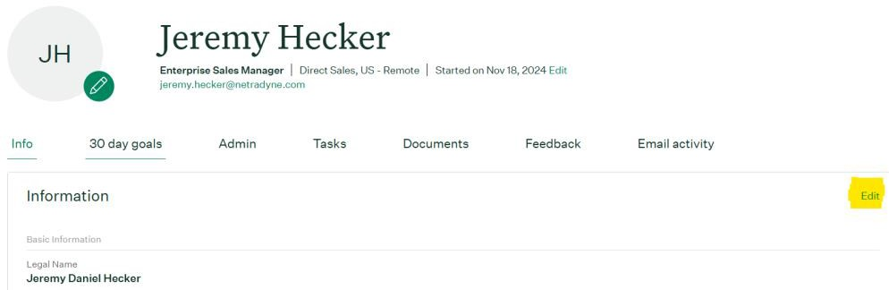

1. Scroll down to the *Additional Information* section.
2. Enter the proper number in the *Email NickName* section.

Standard Email ID nickname convention to be followed by the employees having employee ID

<First letter of first name><First letter of last name><ND><IN/US based on user location><add 2 zeros followed by employee ID>

### Example1:

* + Employee Name - Chethan Gangaraju
  + Employee ID - NDI083
  + Email ID Nickname - CGNDIN00083

### Example2:

* + Employee Name - Mauricio Taxman
  + Employee ID - NDUS00116
  + Email ID Nickname - MTNDUS00116

Note 2: Standard Email ID nickname convention to be followed by the employees NOT having employee ID

### Example1:

* + Employee Name - Chethan Gangaraju
  + Employee ID - Not Assigned
  + Email ID Nickname – chethan.gangaraju

### Example2:

* + Employee Name - Mauricio Taxman
  + Employee ID - Not Assigned
  + Email ID Nickname – mauricio.taxman

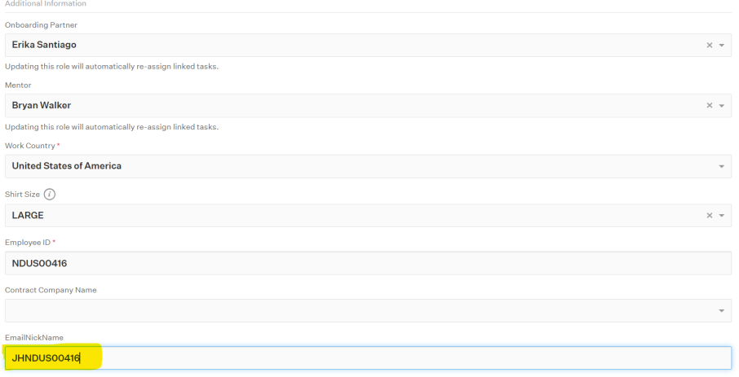

1. 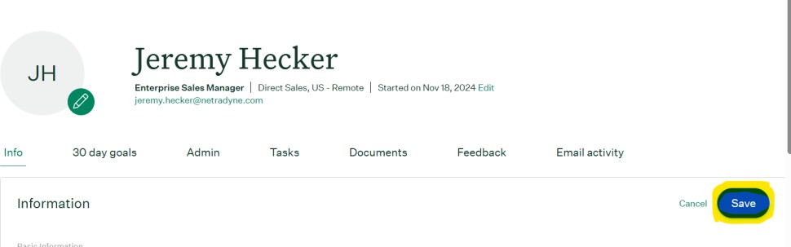Click “Save”

## Conduct

Compliance Checks to this process to be performed through various methods, including but not limited to reports, internal/external audits, Awareness training/assessments and feedback to the process owner. Non-compliance will be escalated to the Netradyne leadership team.

## Exception

Exception to this procedure must be approved through the Netradyne Exception Process.

## Terms/Acronyms

|  |  |
| --- | --- |
| **Term/Acronym** | **Definition** |
| O365 | Microsoft office 365 |
|  |
|  |
|  |
|  |
|  |
|  |

## References

### Policies

*Netradyne Information Security Policy & Procedure.pdf Netradyne Information Security Exception Process.pdf Acceptable Usage Policy.pdf*

### Process/Procedures

*NETRADYNE DISASTER RECOVERY PROCESS.pdf NETRADYNE BUSINESS CONTINUITY PLAN.pdf*

*Netradyne Vulnerability & Patch Management Process.pdf NetradyneSecurityIncidentResponsePlan.pdf*

*Netradyne IT Incident Management.pdf*

## Appendix A: Document RACI Matrix

|  |  |  |  |  |  |  |
| --- | --- | --- | --- | --- | --- | --- |
| **Role/Activity** | **Document Owner/Functional Area Lead** | **Document Contributor** | **ND**  **Leadership** | **Functional Area Team** | **InfoSec** | **All ND Member(s)** |
| **Ensure document is kept current** | A | R | I, C | R, C | C | I |
| **Ensure stakeholders are kept**  **informed** | A | R | - | R | C | - |
| **Ensure document contains all relevant information** | A | R | I, C | R, C | C | I |

|  |  |  |  |  |  |  |  |  |
| --- | --- | --- | --- | --- | --- | --- | --- | --- |
| **Ensure document adheres to document**  **governance policy** | | A, R | | R | I | R, C | R, C | I |
| **Provide SME advice** | | I, R | | A, R | I | R, C | I, C | I |
| **Gathering and adding**  **document contents** | | I | | A, R | I, C | R, C | C | I |
| **Document Approval** | | A | | R | I, R | I | I, R | I |
| *Key* | | | | | | | | |
| *R* | Responsible | |  | | | | | |
| *A* | Accountable | |
| *C* | Consulted | |
| *I* | Informed | |